**OMM500N Assignment4**

1. In February, the total cost of transportation and inventory cost was $1.4 million, and the estimated cost for March is roughly the same amount. Using the model you have developed, what is the average monthly cost in April and May if the logistics operation at Dellmar is optimized? What should be Dellmar's production and shipping schedule? How much inventory should Dellmar keep at each distribution center?

Problem Statement:

Use Yi as a 0/1 to identify whether fixed cost

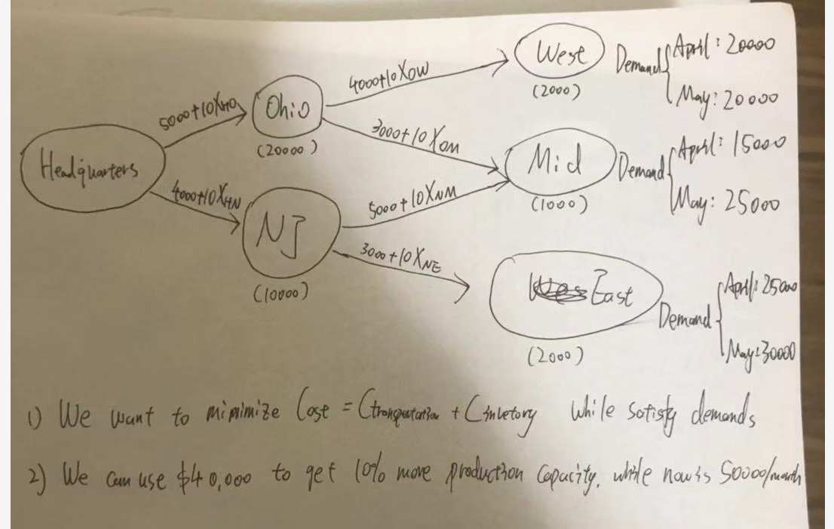



Solution: 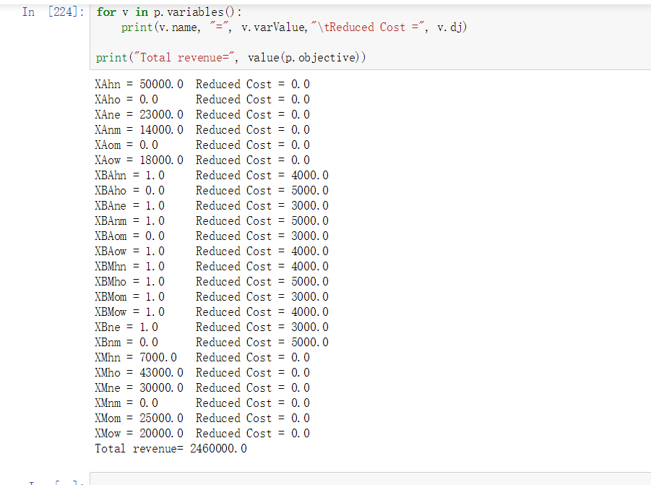

The average per month is 2460000/2 = 1300000, 1.3 million

2. What is the effect on the total transportation and inventory cost if Dellmar decides to increase its production capacity by 10%?

Answer:

It will turn the maximum capacity to 55000

Reformulate the model, this would reduce the average cost monthly , but it would be more costly than don’t do that considering of you have to pay $40000/month to enhance maximum capacity.

3. In order to decrease delays in filling customer orders, Ron is considering increasing the minimum inventory at each distribution center from 0 to 500 or possibly even 1,000 Cushion‐Air‐Pro units per month.Is it possible to institute such a policy given the current capacity of 50,000 units per month? Is it possible to institute this policy if plant capacity were to increase by 10%?What would be the effect of such a policy change on total transportation and inventory costs?

Answer:

It’s not possible to institute that given the current capacity( infeasible )

It’s possible to institute that given 10% more capacity

Cost with hedge 500/1000:

500 min_inventory :1257500

1000 min_inventory :1297500